

Indian Institute of Technology  
Delhi

**SURA 2014 PROJECT PROPOSAL**

DESIGN AND OPTIMIZATION OF SHELL AND TUBE HEAT EXCHANGER THROUGH CFD SIMULATION

**Student Information:**

**Nitin Agrawal Vedant Bhardwaj**2012ME10692 2012ME10737Mechanical Engineering Mechanical Engineering[nitinagrawaljmp@gmail.com](mailto:nitinagrawaljmp@gmail.com) [vedant.iitd@gmail.com](mailto:vedant.iitd@gmail.com)+91-8375820205 +91-7503758084CGPA: 8.413 CGPA: 8.095

**Facilitator:**

**Dr. Prabal Talukdar**

Associate Professor

Department of Mechanical Engineering

Indian Institute of Technology Delhi

Hauz Khas, New Delhi 110016, India

Ph: +91 11 26596337(off)

+91 9818239503 (cell)

E-mail: [prabal.talukdar@gmail.com](mailto:prabal.talukdar@gmail.com)

[prabal@mech.iitd.ac.in](mailto:prabal@mech.iitd.ac.in)

**Head of Department:**

**Prof. S.R. Kale**  
Dept. of Mechanical Engineering  
IIT Delhi

**Scenario:**

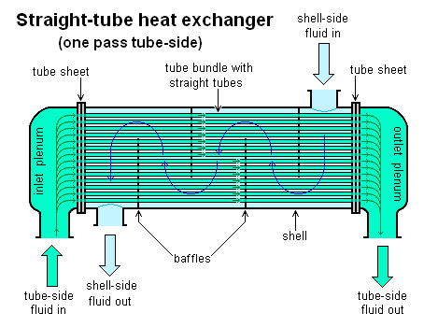

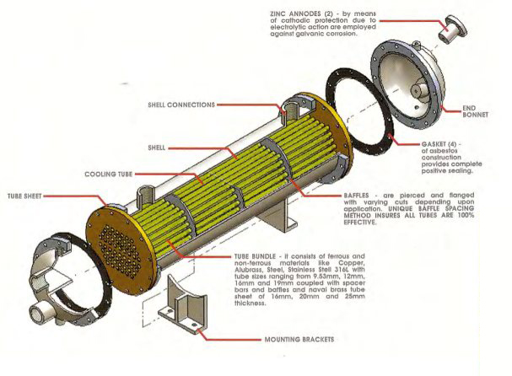

A heat exchanger is a device that is used for transfer of thermal energy (enthalpy) between

two or more fluids, between a solid surface and a fluid, or between solid particulates and a

fluid, at differing temperatures and in thermal contact, usually without external heat and

work interactions.

These are tubular exchangers in which transfer of heat occurs between two fluids, one fluid flowing inside the tube and other in the shell (outside the tube). These are non-compact exchangers and are extensively used in industries as they can be custom designed for any capacity and working conditions.

**Objective:**

The key objective of this project is

* Modelling and simulation of a shell and tube heat exchanger
* To optimise the **shell and tube heat exchanger** for a certain heat transfer rate
* To design shell and tube heat exchanger using thermodynamic model

using **Computational Fluid Dynamics simulation**.

**Approach to the proposed R&D project:**

We will be simulating the shell and tube heat exchanger and carrying out the analysis of the results we get.

The software which we will be using is **Ansys Fluent**-a fully featured fluid dynamics solution for modelling flow, physical and thermal phenomena. The software offers insight into how a product design will behave in the real world, all before a single prototype is built.

The **parameters** required for the optimization of the rate of heat transfer are as follows:

* Surface area density
* Tube pitch
* Baffle shape and position
* Shape and dimension of the tube and shell.
* Fluid properties, temperature, pressure drop
* Shell nozzles and Impingement methods

The data obtained in the post processing of the simulation will help us to get improved heat transfer by giving us the optimized value of our parameters.

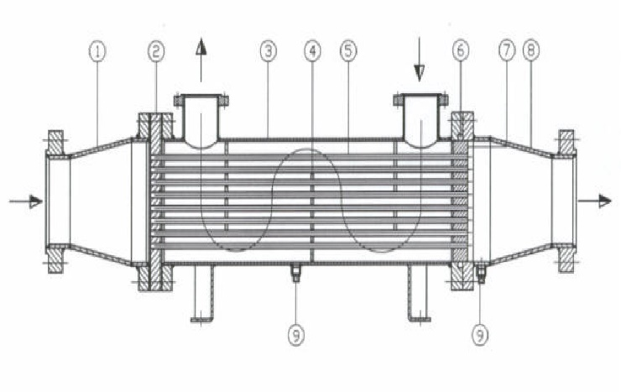

*The following table summarises the approach*

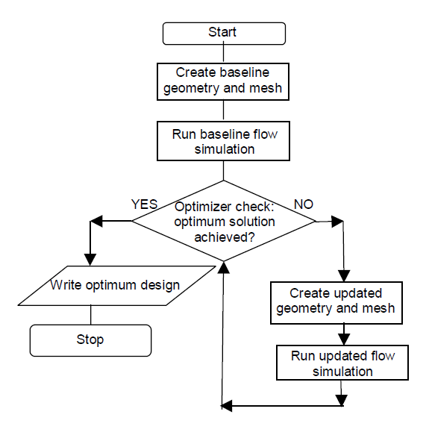

**Novelty Aspects:**

This project will help in finding the **optimum solution** for the shape and design of the heat exchanger which further will increase the heat transfer between the fluids. This will increase the cleanability and life of the heat exchanger.

The aim of the project would also be to come up with a new design of the tube and baffles for efficient heat transfer, less energy loss for given fluid conditions.

Finally, we will compare the CFD simulation data with thermodynamic simulation data.

**Duration, Facilities and Budget required:**

The duration of the project is expected to be eight weeks. However, we plan to further pursue this research in the guidance of the facilitator in an independent manner so that our work will lead to a publication in a reputed journal. Since the nature of project is mostly theoretical/ computational in nature, we may require some simulation facilities and monetary support (if any).

**References:**

1. Fundamentals of Heat Exchanger Design – Ramesh K Shah, Dusan P. Sekulic
2. Heat Exchanger Design – Arthur P. Fraas
3. <http://www.funke.de/files/funke_shell_tube_he_e.pdf>
4. <http://publications.lib.chalmers.se/records/fulltext/155992.pdf>
5. <http://www.unix.ecs.umass.edu/~rlaurenc/Courses/che333/Reference/exchanger.pdf>